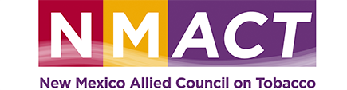

2020 NMACT Day at the Capital
AGENDA
8:30 am Registration, Catered Hot Breakfast, and Networking
Location: La Posada de Santa Fe, a Tribute Portfolio Resort & Spa
330 East Palace Avenue, Santa Fe, NM, 87501
9:00 am – Welcome & Introductions
9:10 am – 10:15 am Panel Discussion: The Vaping Crisis in New Mexico
Dr. Leah Nelson, MD Addiction Medicine Fellow, PGY4,
UNMH (Expert Contributor, “VAPE” Documentary -Christopher Productions)
Dr. Dona Upson, MD, Pulmonologist, NM Veterans Affairs Health Care System-
Raymond G. Murphy Medical Center (Expert Contributor, “VAPE” Documentary -Christopher Productions)
Dr. Robert Taylor, MD , Cardiologist and Board President,
American Heart Association in Albuquerque
David Tompkins , Manager, Community Health Initiatives, New Mexico Tobacco Use Prevention and Control Program
10:15 am – 10:25 am BREAK
10:25 am to 11:00 Advocacy Training - How to Speak to Your Lawmaker (Janno Vallo)
11:00 am – 11:10 am Conclusion/Wrap Up
11:10 am Walk or Shuttle to the Roundhouse for Lawmaker Meetings and Press Conference
11:30 am (New Mexico State Capitol Room 311)
Legislator Meet & Greet (drop by)
Individual time for you to meet with Your Legislators.
1:00 pm Press Conference (New Mexico State Capitol Rotunda)
1:45 pm Debrief, thank you cards and catered boxed lunch (New Mexico State Capitol Room 311)
Brown Ribbon Remembrance for those that have lost their lives to tobacco

